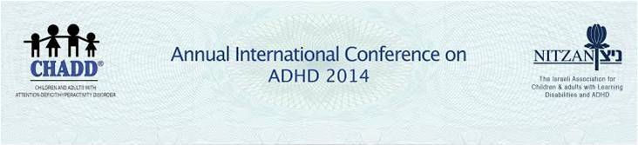
Coach Your Child to Success
E.C.C – EMOTIONAL COGNETIVE COACHING
Duration – 7 hours
9:00- 9:30 Gathering
9:30-10:15
Part 1 – Lecture: The Art of Parenting
Description of the method and the results of the study that has proved its effectiveness.
10:15-10:30 Coffee Break
10:30-12:00
Part 2 – Workshop 1: Departing the "Swamp" for a Bright Future.
An experiential workshop, in which we shall experience some of what the method offers and experience the training process itself.
12:00-13:00 Lunch
13:00-14:45
Part 3 - Workshop 2: Progressing Toward the Goal.
An experiential workshop, in which we shall experience some of what the method offers and experience the training process itself.
14:45-15:00 Coffee Break
15:00-16:00
Part 4 – Open Discussion
_________________________________________________________The workshop will be conducted by Dr. Maly Danino and Mrs. Anat Katznelson
Dr. Maly Danino – Ph.D in Counseling and Human Development. Developer of the parent coaching method at Nitzan. Coach and facilitator of parents' groups and trainer of professionals in working with parents and children with learning disabilities. Author of Coach your Child to Success (2011).
Mrs. Anat Katznelson – M.A in Psychology. Resident psychologist of Nitzan's National Association. Senior specialist in Diagnosis and Treatment of LD and ADHD. Coach, instructor and group facilitator. Director of the parent coaching program in Nitzan.

